Lab 6 Report

**Introduction:**

To begin with we were provided code that drew some what of a maze figure with random lines, walls being removed. Our task in this lab was to create an actual maze by using a disjoint set forest. We were instructed to remove a wall if the cells that were separated by that wall belonged to different sets, then we had to unite those two cells using the union function in the disjoint set forest class. We had to repeat this process until all of the cells belonged in a single set.

**Proposed Solution:**

Well, we were provided with the pseudo code on how to remove a wall if two cells belonged to different sets. So, I just simply followed the pseudo code which stated that we make a disjoint set forest where each cell is its own set initially. I made a while loop so that as long as the number of sets is greater than one, random walls get selected and checked to see if they’re in the same set or not. If they aren’t, the wall gets removed and then the two cells get combined using union, if they’re in the same set, nothing happens. That’s pretty much it, I removed the walls that separated two cells that weren’t in the same set, then I joined the two cells together.

**Experimental Results:**

Below is a screen shot of the maze that was created when I removed the walls and combined the cells from different sets.

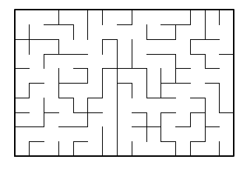

When I compared the times from the normal union method and the union method that uses compression, I found that they were very similar, in some cases identical. Below are the times for the uncompressed union function. These times include removing the wall, I found that union alone was initially giving me 0.0ms, so I included the if statement that removes a wall.

Below is a screen shot of the code I used to determine the times for both the union with compression and the union without compression. Union represents the union without compression and union2 represents the union with compression.

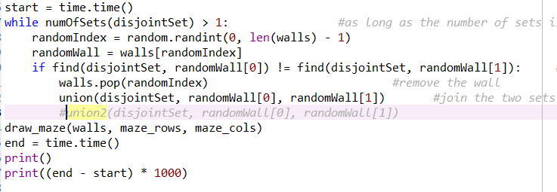

**Conclusion:**

I found that there is a very slight difference in times between the union with compression and union without compression. I found that the union with compression is a little bit faster than the union without compression, but not by much. I learned how to determine if things are in the same set or not by using a disjoint set forest.

**Appendix:**

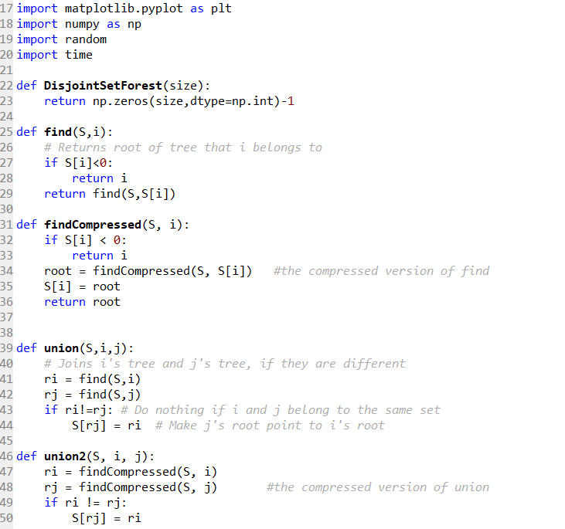

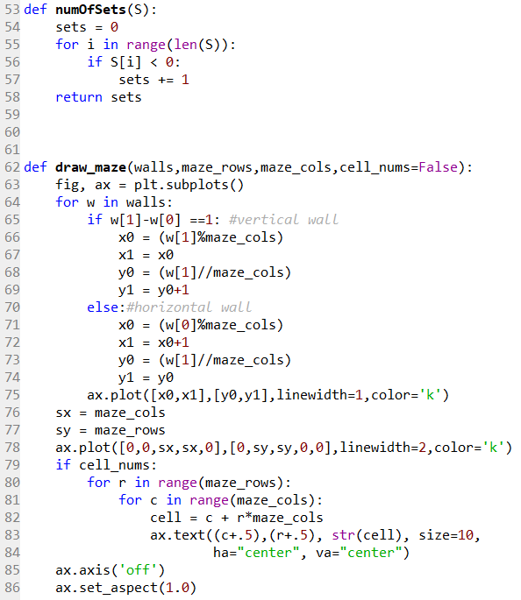

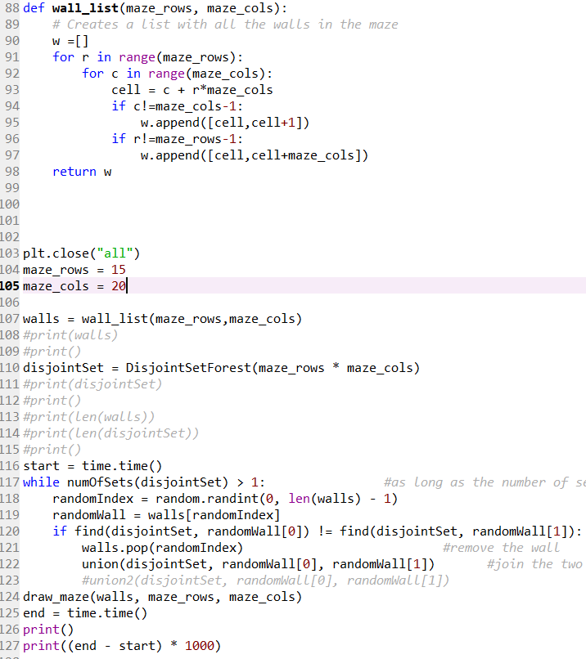

“I certify that this project is entirely my own work. I wrote, debugged, and tested the code being presented, performed the experiments, and wrote the report. I also certify that I did not share my code or report or provided inappropriate assistance to any student in the class.”

Joey Roe